**SOCIAL MEDIA AGENCY REPORT**

**Social Media Agency**

This system is built for a social media agency to maintain all their talents records, their deliverables, their post times and all other activities.

**System Requirements:**

* This application is built for a social media agency, which recruits talents based on their category of the talent like, Dancing, Acting, Comedy, Sports, Arts etc.
* These talents are enrolled in different social media applications like Instagram, Facebook, Tik Tok, YouTube, Roposo, Moj.
* The agency has a manager who keeps track of all the talents activities and prepares a report and monitors all the posts uploaded by the talent.
* The Agency also receives Advertisements from different brands, where the manager assigns these advertisements to the talents and gives them deliverable details.
* The advertisement can either be Paid promotions, Collaboration or a Barter promotion. Depending on the requirements of the brand, the manager will assign the deliverables to the talent and maintains all the details such as start date, end date and the no of posts a talent must upload, details of the product.
* One talent can work on multiple Social media applications, and get paid for all the applications they would work on.
* Manager also prepares a report of the progress about the talent, such as the number of posts uploaded, the ranking etc.
* A dashboard is maintained which would have the details about the number of pictures, videos, stories uploaded. Along with the number of shares, likes, comments a particular post gets.

**WEBSITE REQUIREMENTS:**

* MySQL workbench
* PYTHON FLASK application
* SUBLIME – text pad

**STEPS TO DEPLOY:**

* Create all the required tables in MYSQL workbench
* Add the initially required data to these tables. Not all the tables will have the data in the beginning as all the tables will get data as and when the UI has values.
* The code for the UI is written using HTML and CSS. The html codes are all save with html extension and css codes with the css extension.
* The required code for the UI and to connect the database and make a running system we can write the code in subline editor and save it with a .py extension.
* Once everything is ready, the code can be run on our terminal with the python command python program_name.py
* Folder structure to be followed is: All the python scripts are in general folder, all the css files should be saved under the static folder and the html codes will be under the templates folder.

**SCREENSHOTS:**

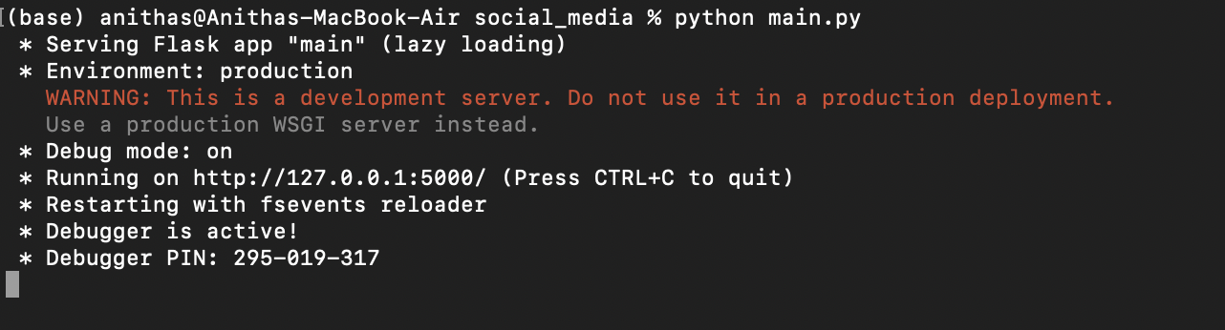

Python script is run as above and the output can be seen in the link: <http://127.0.0.1:5000/>



*Initial page*

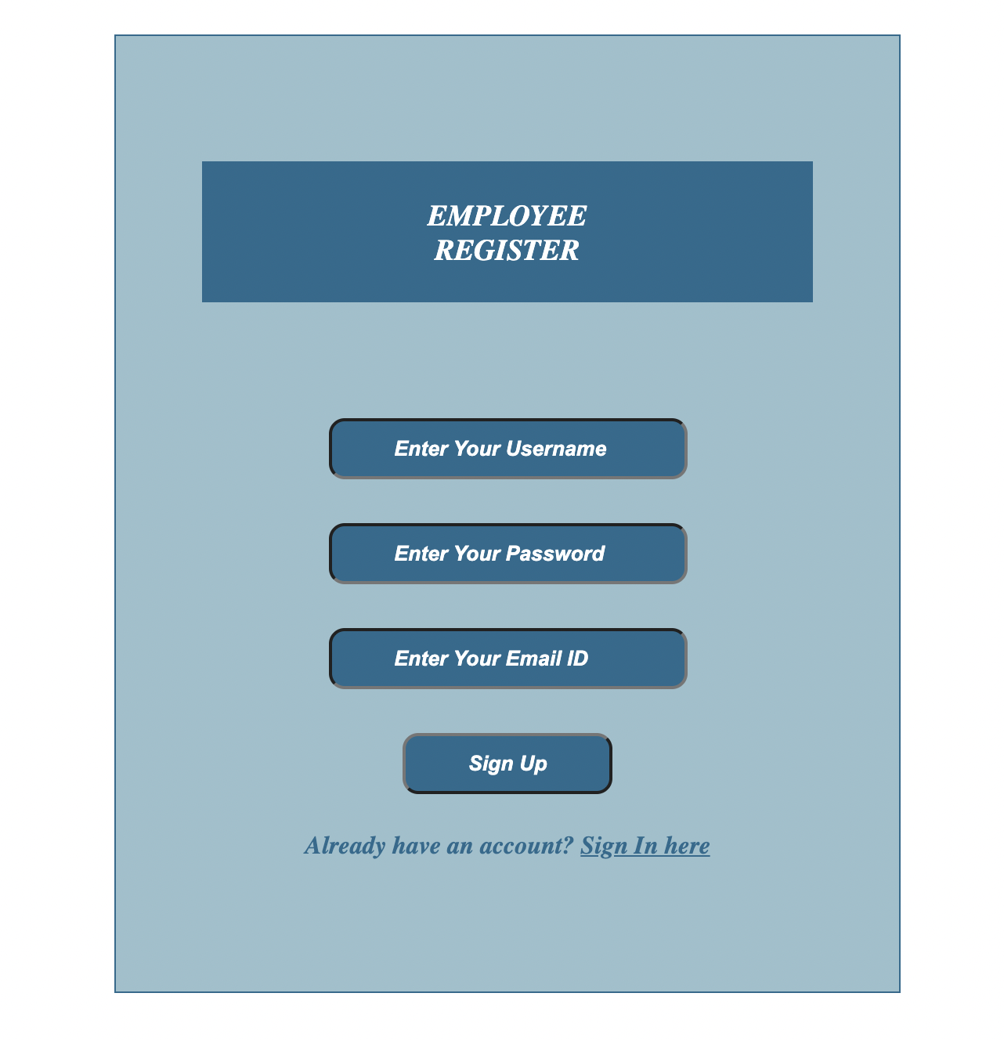

*Employee sign up page*

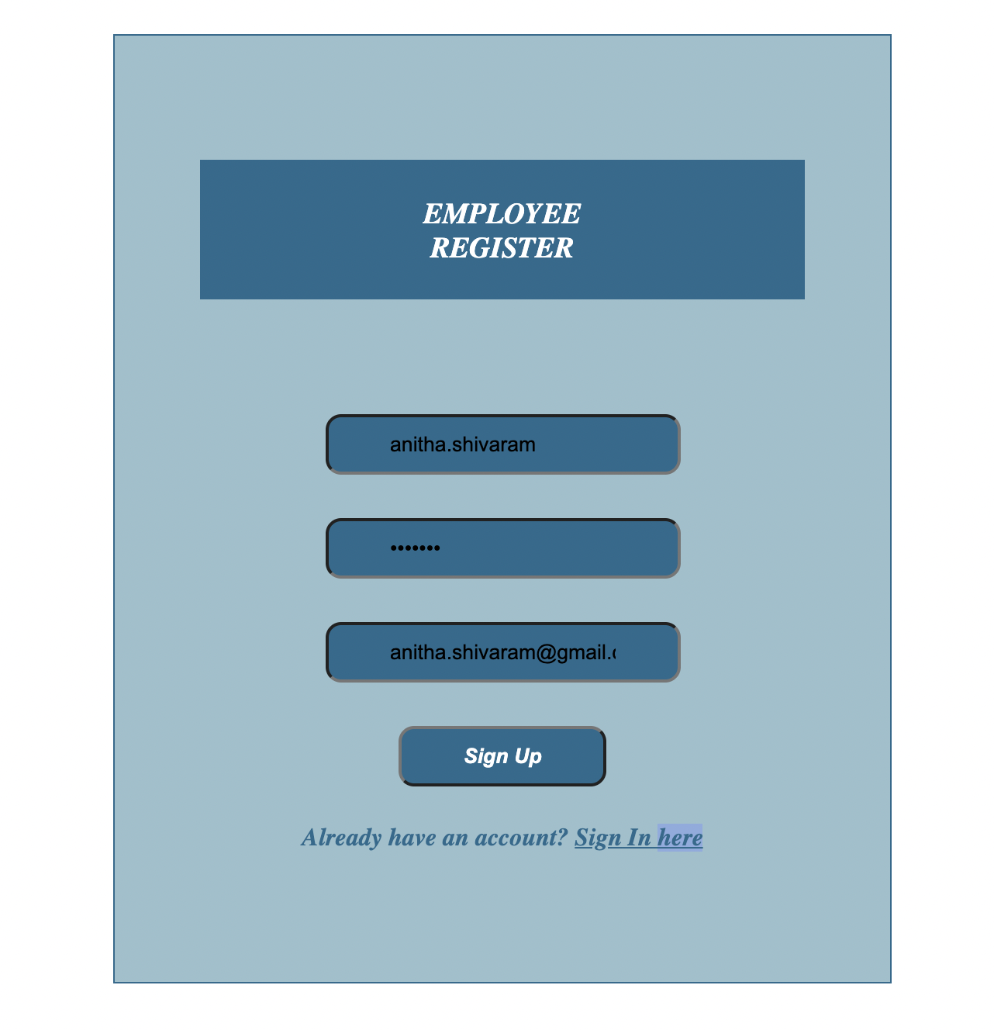

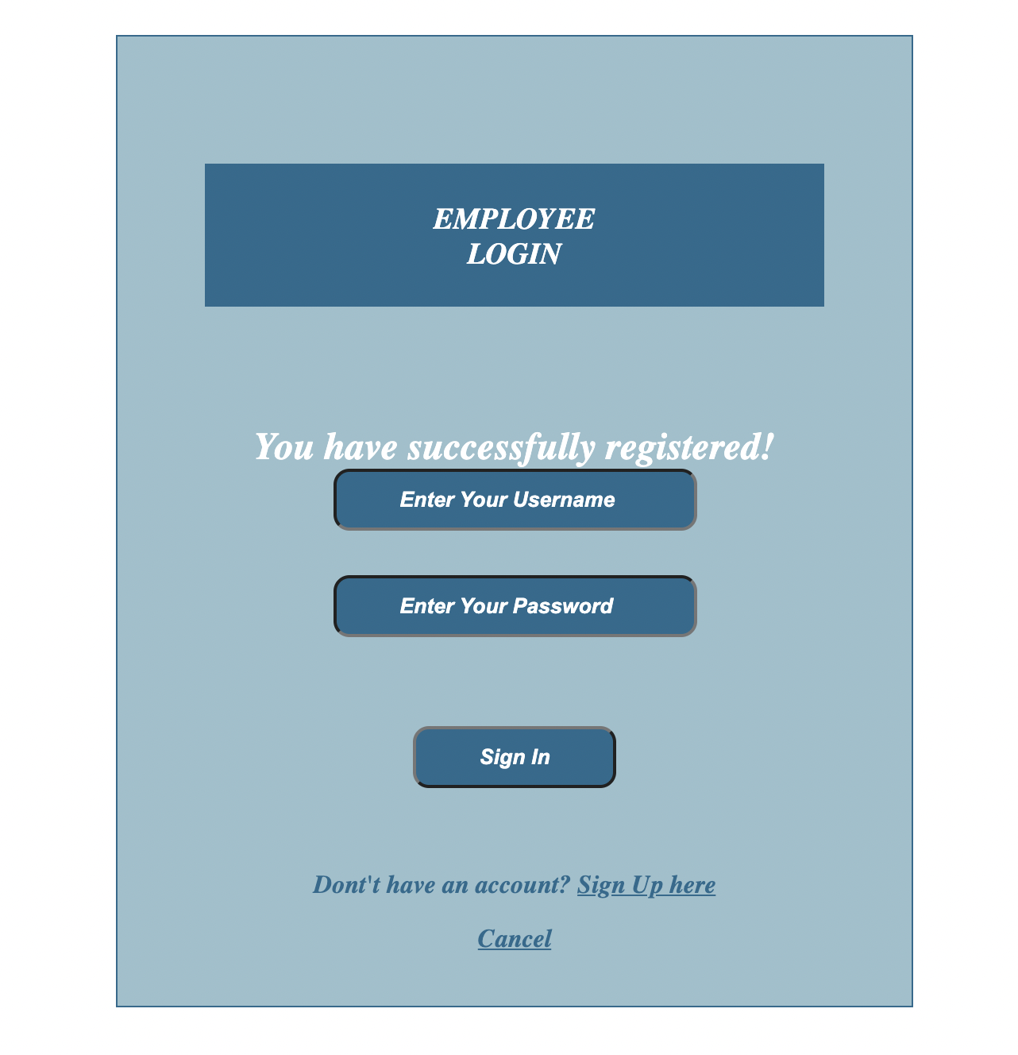

*If the correct details are entered, an account will be created.*

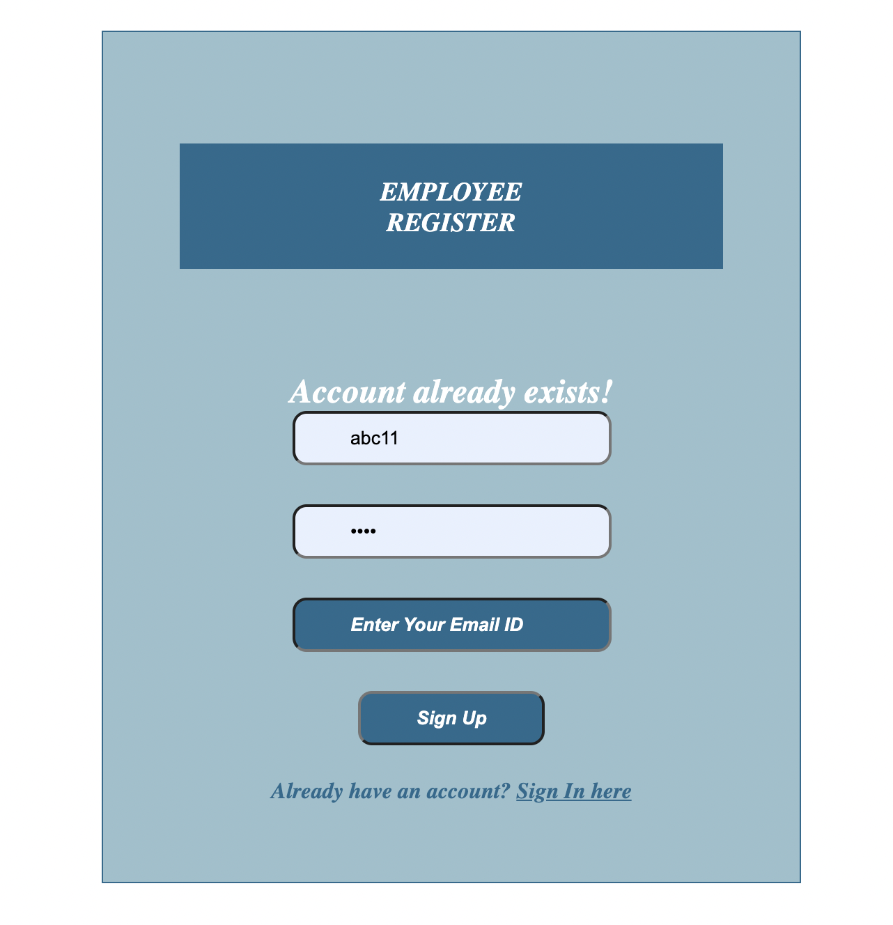

*If account already exists*

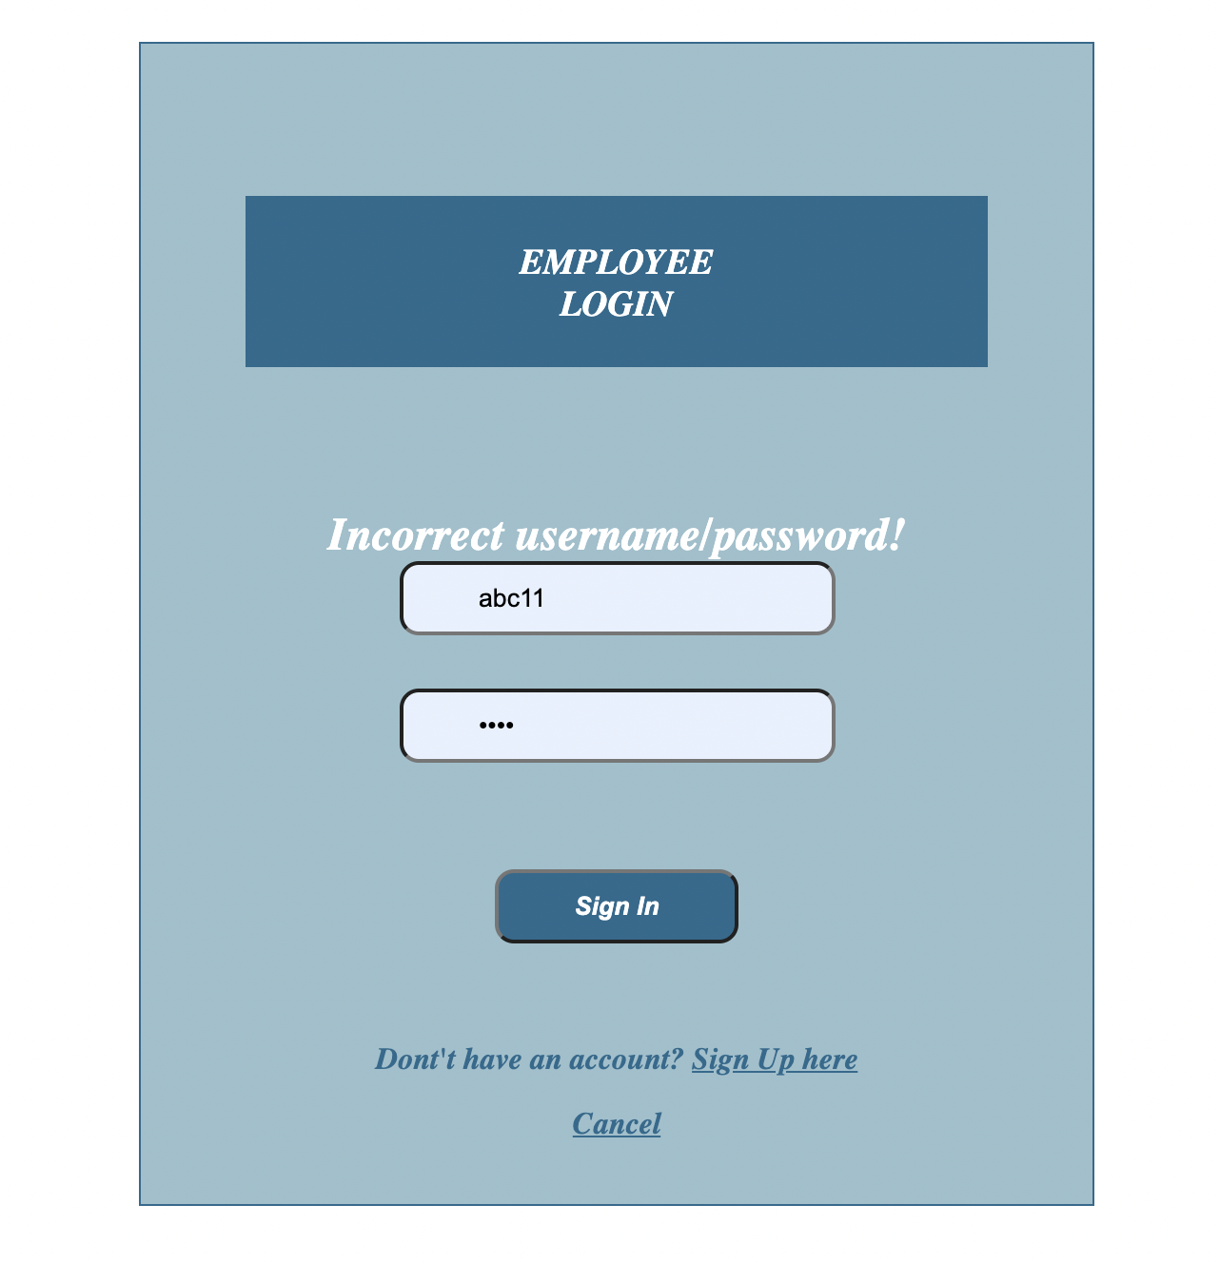

*If wrong password is entered while log in*

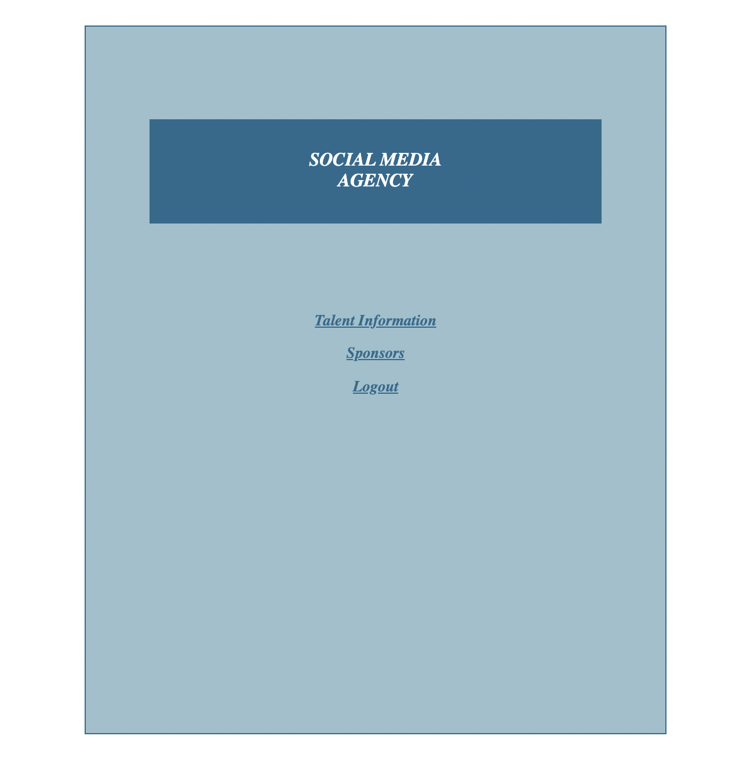

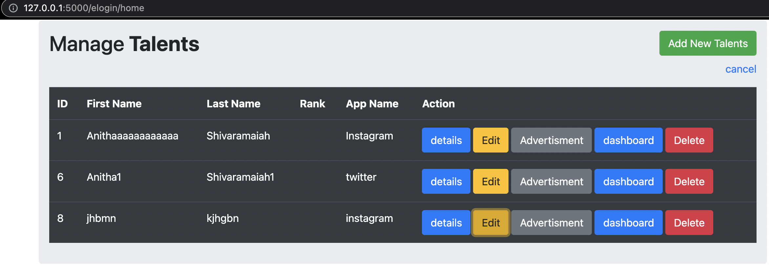

*Initial talent details:*

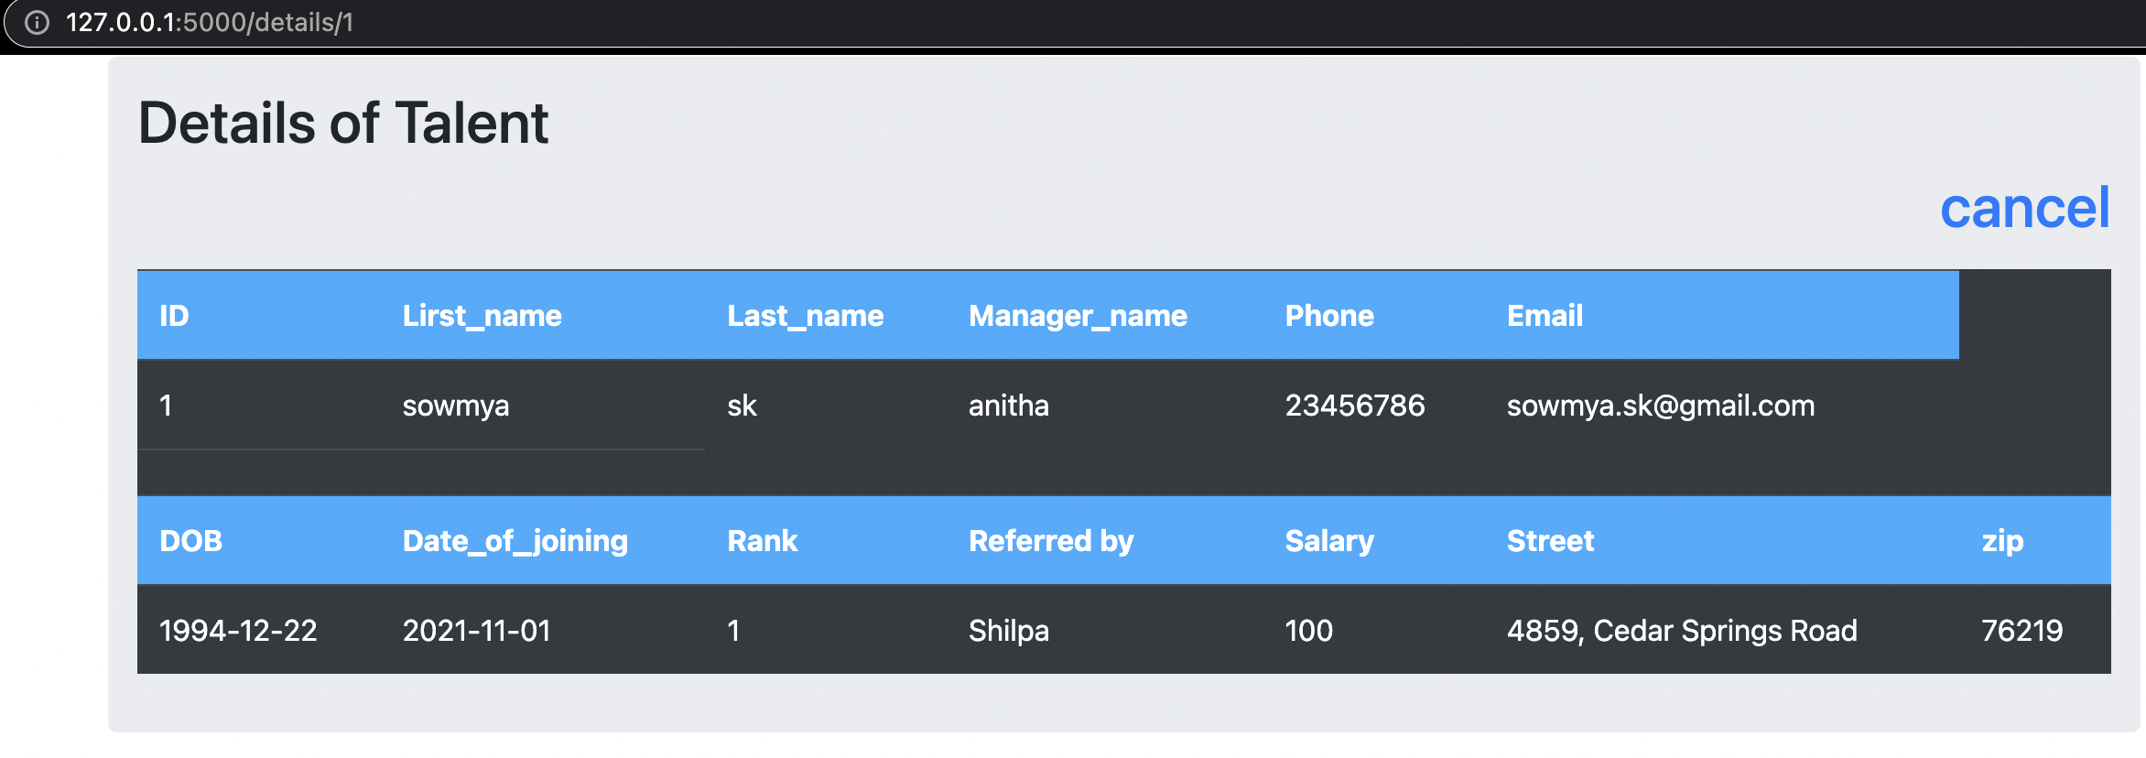

*Details screen*

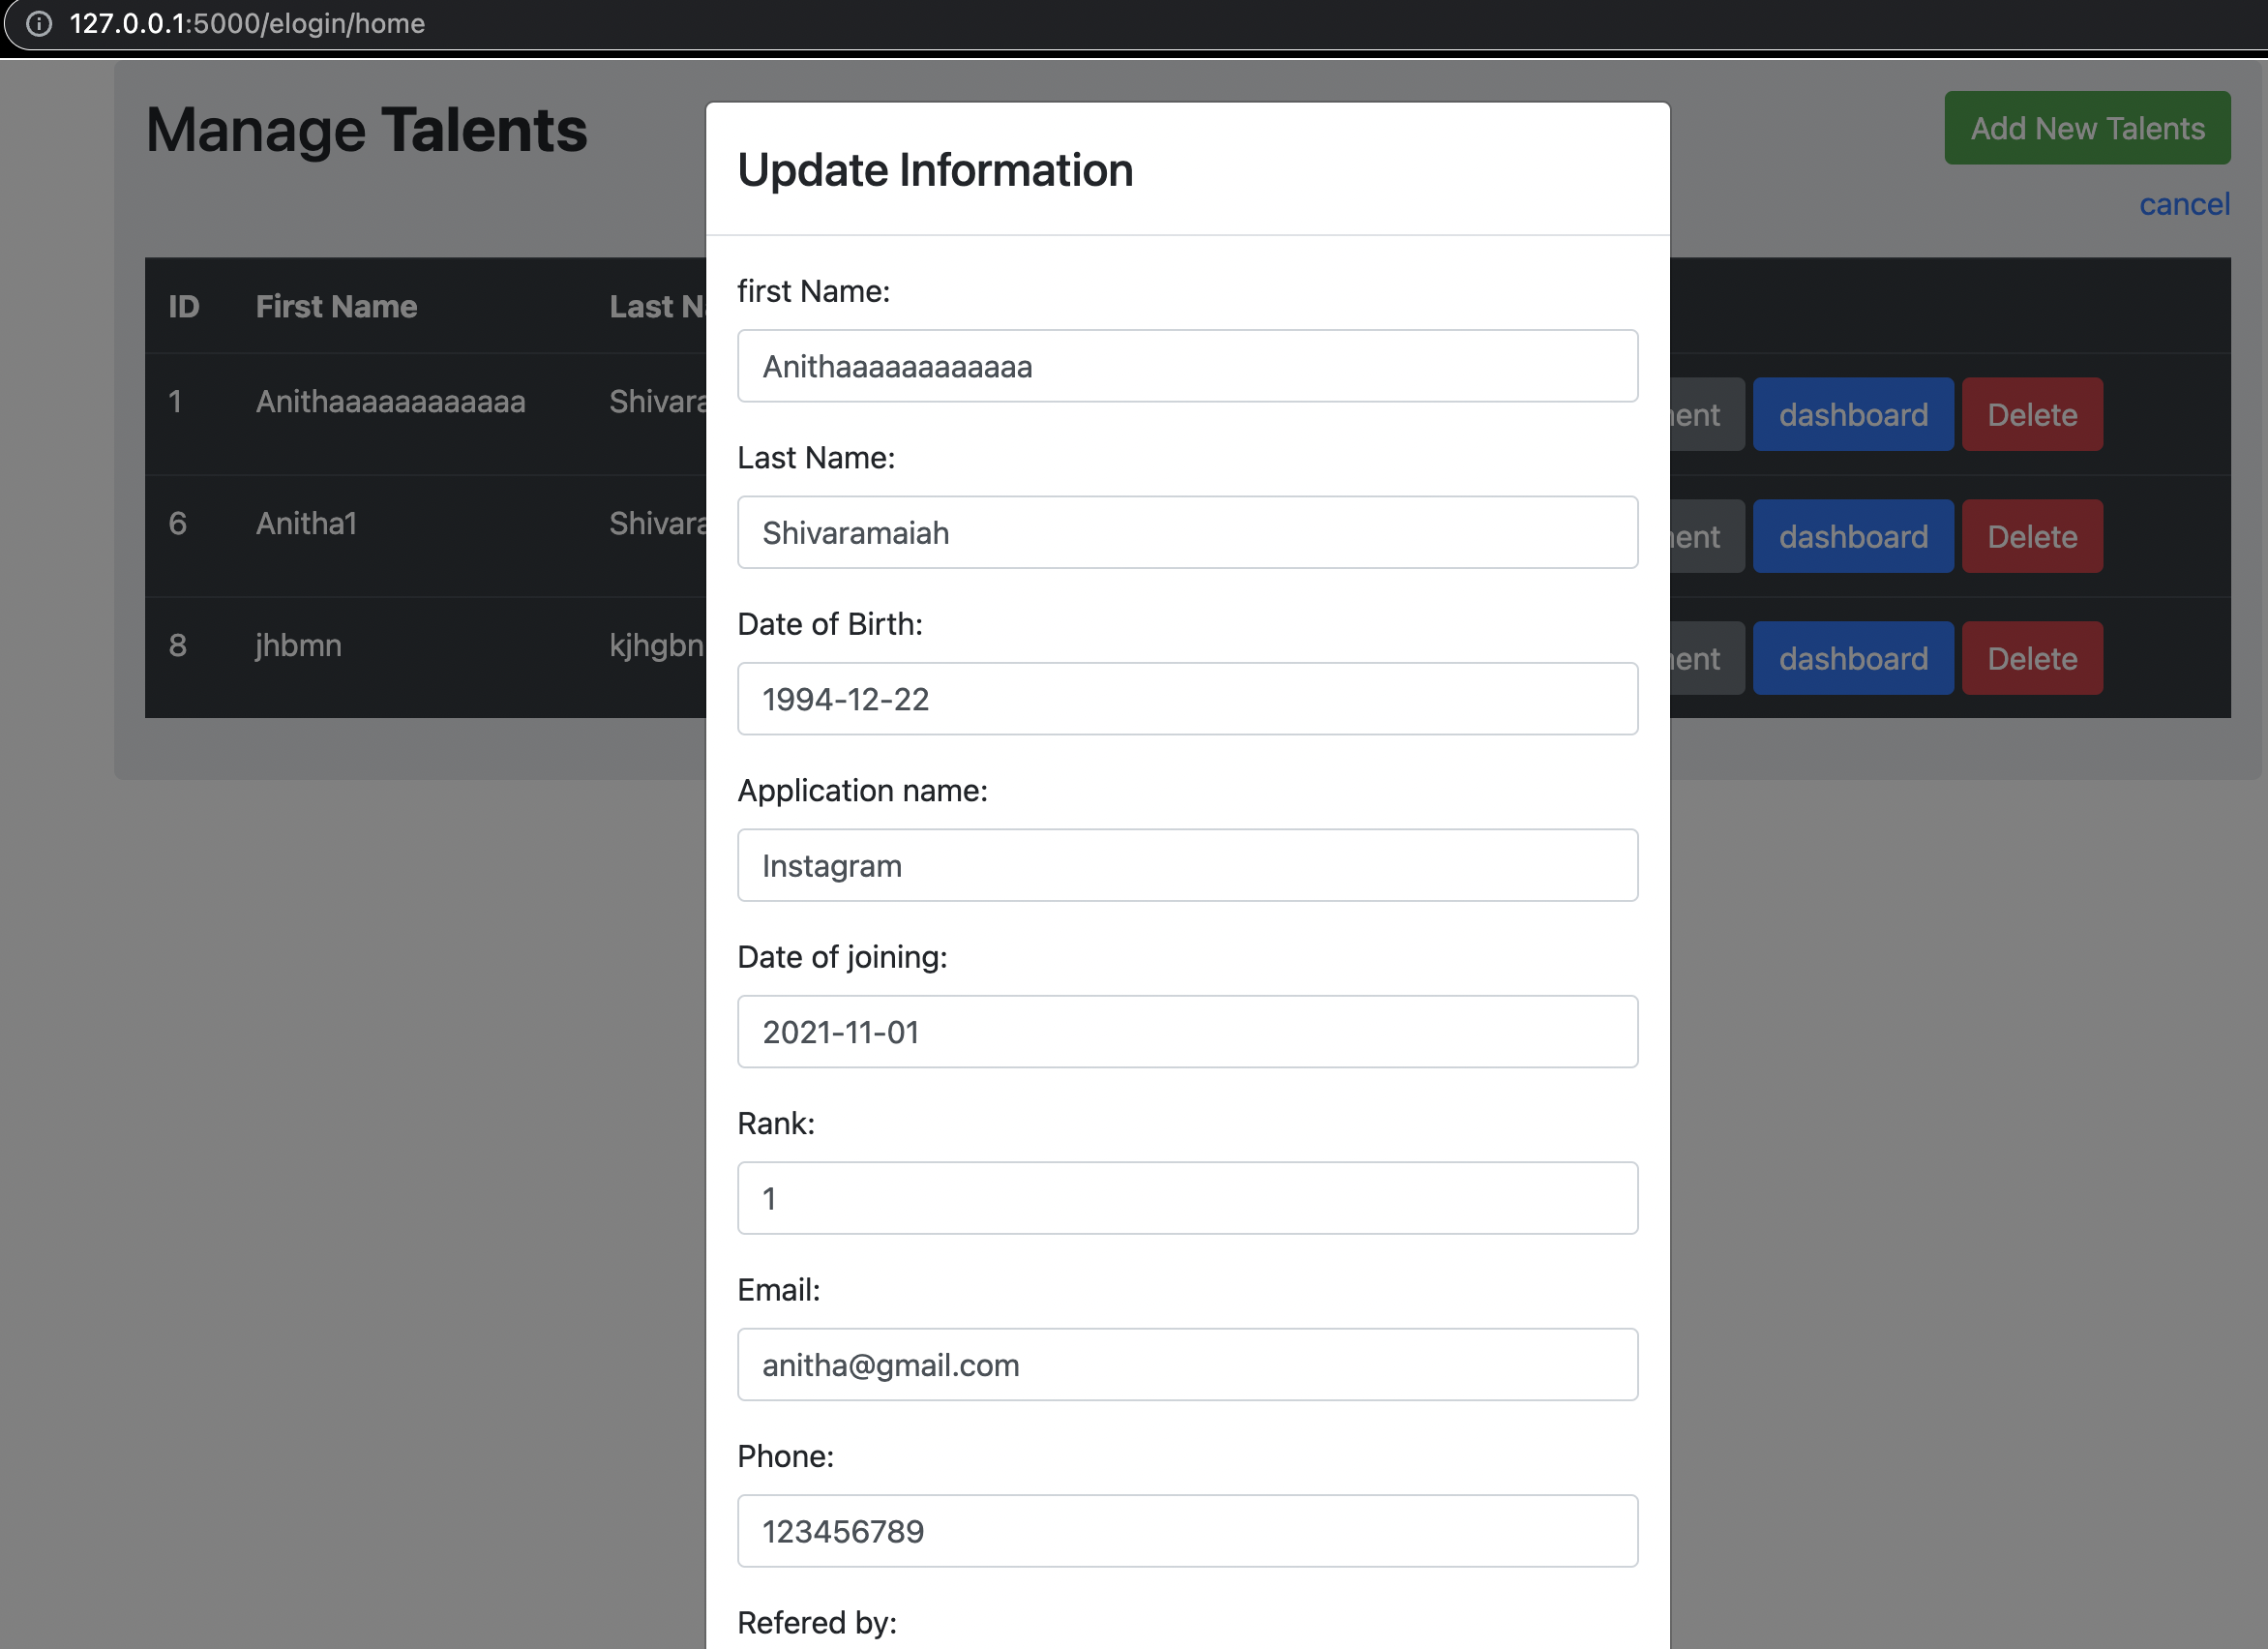

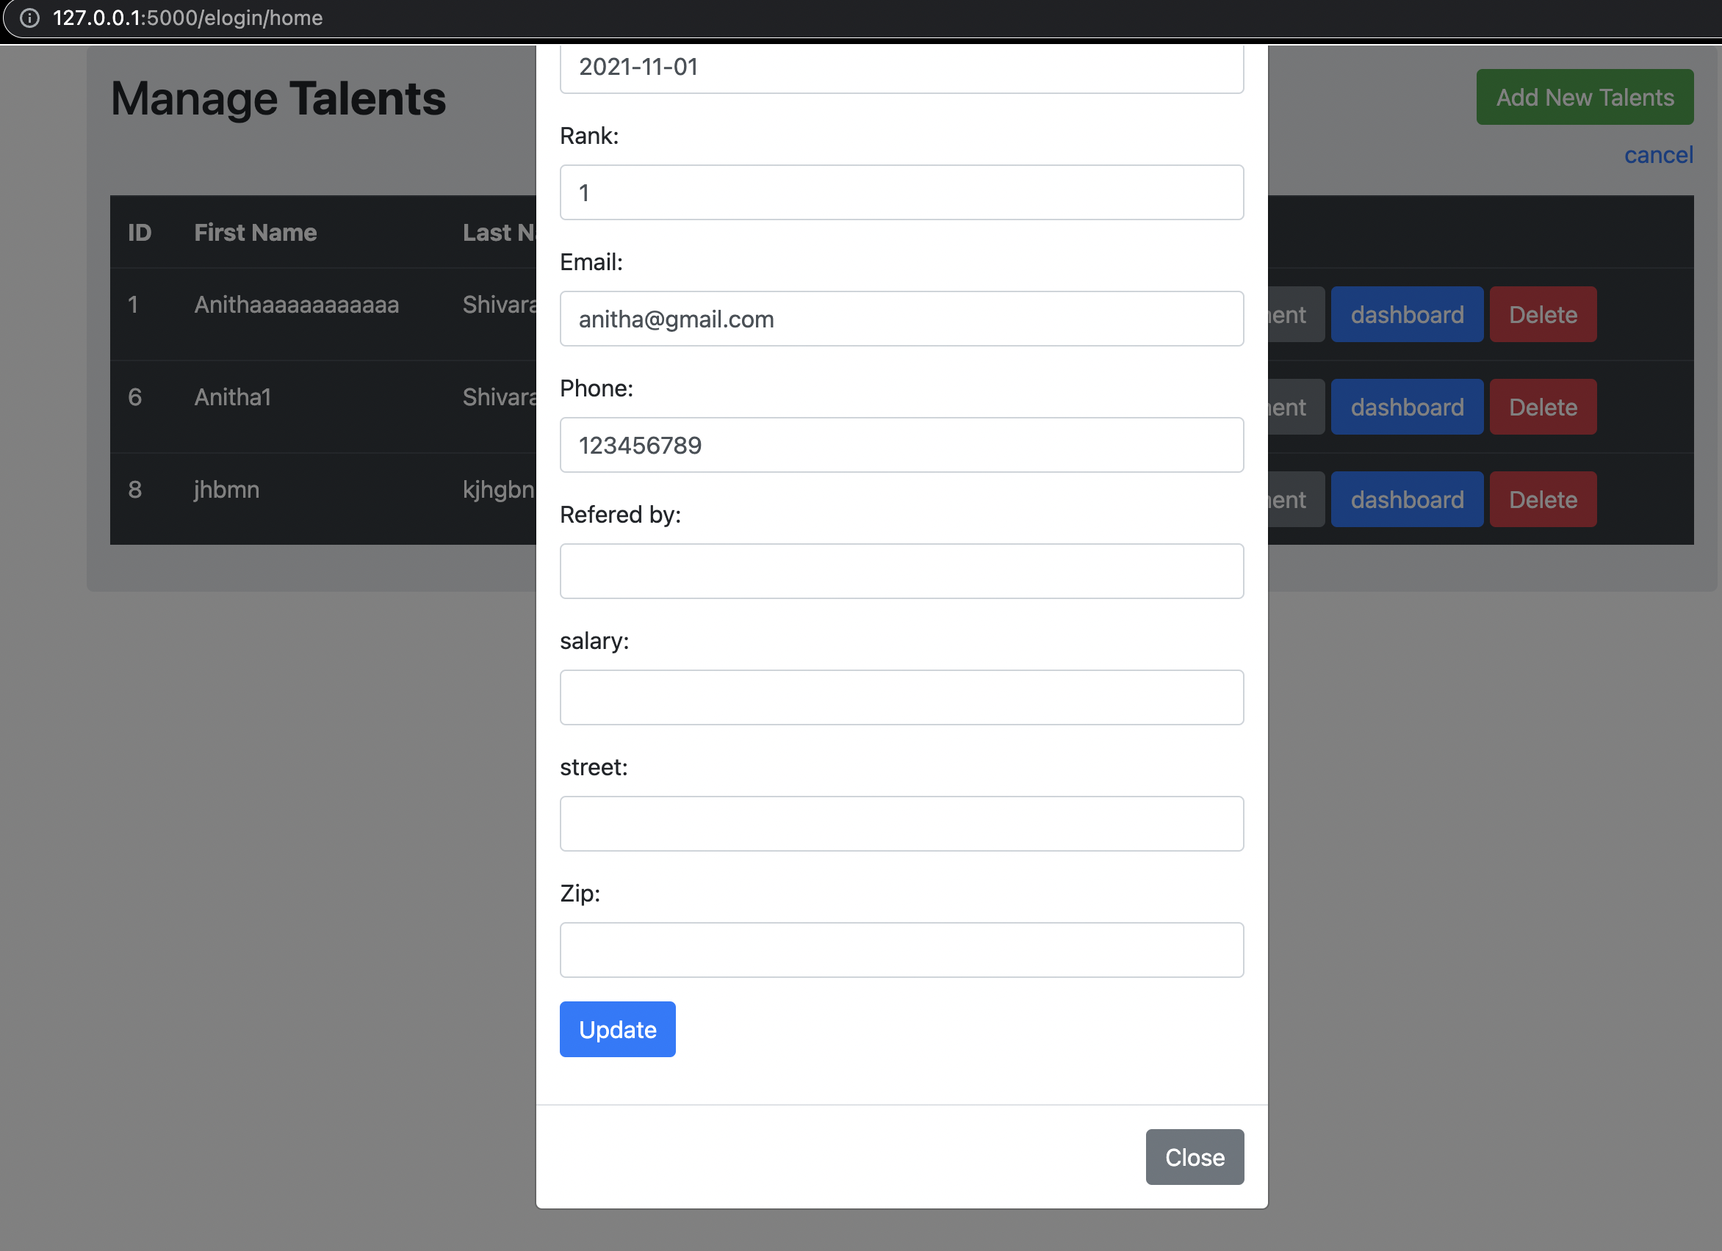

*Editing the talent information*

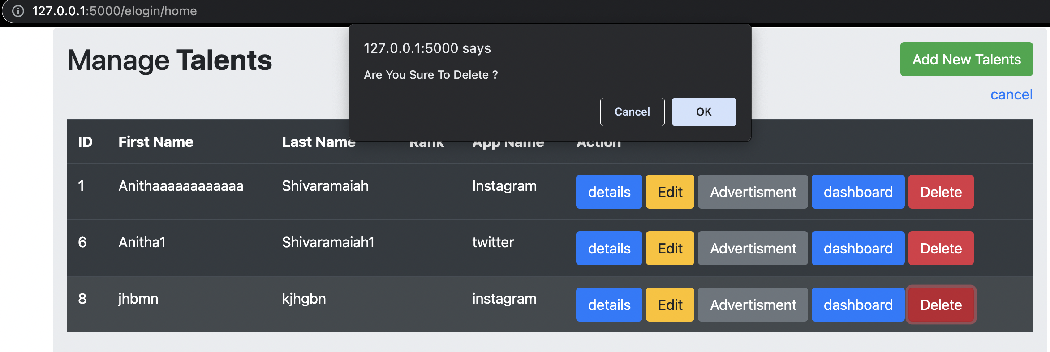

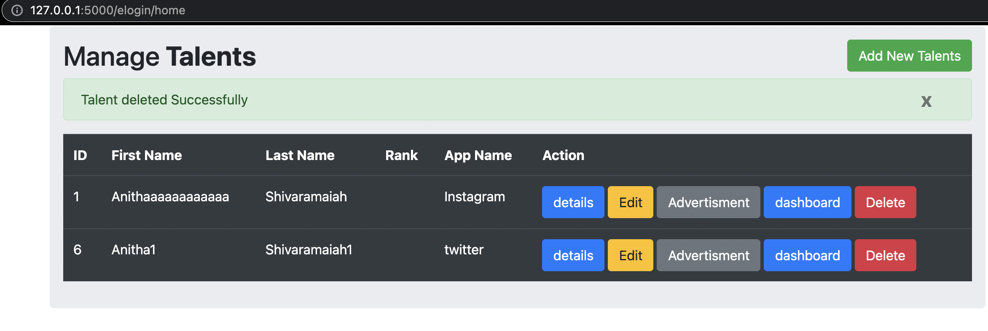

*To delete a particular talent information*

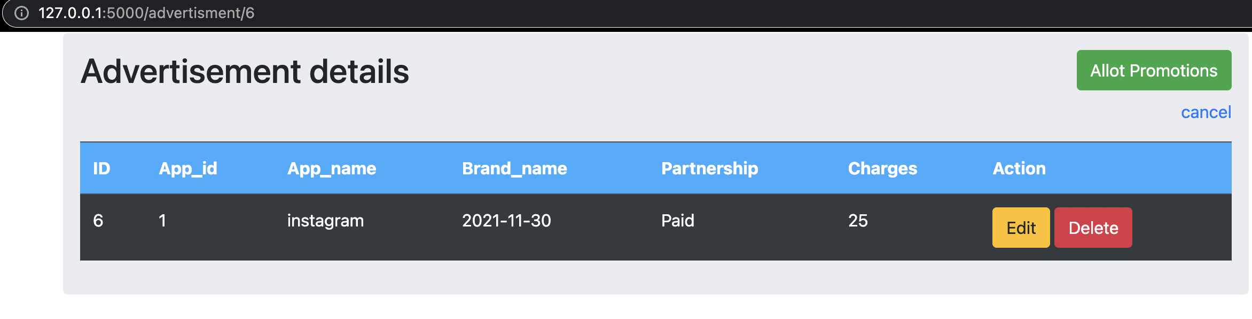

*Advertisement screen*

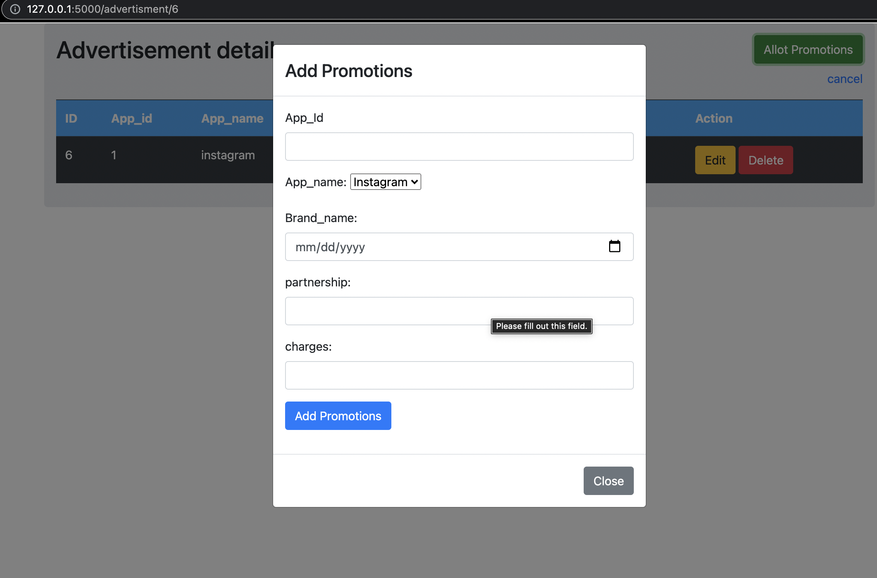

*Manager will allot promotions to the talent*

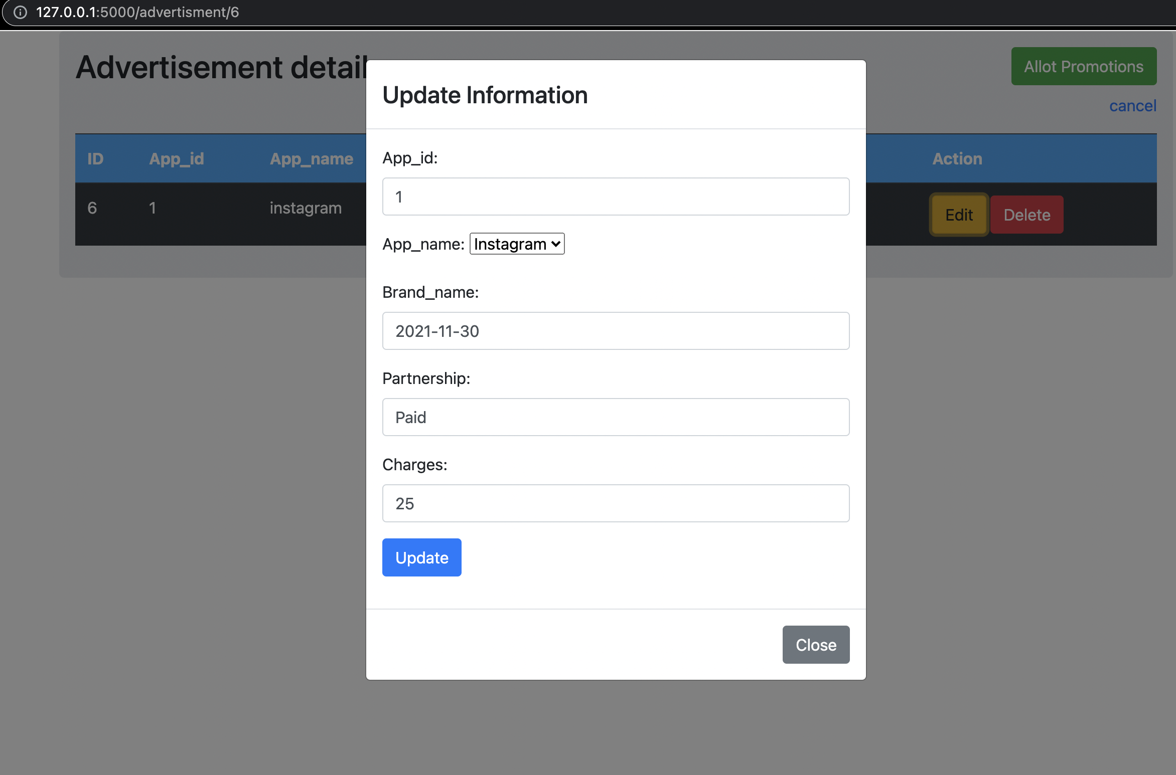

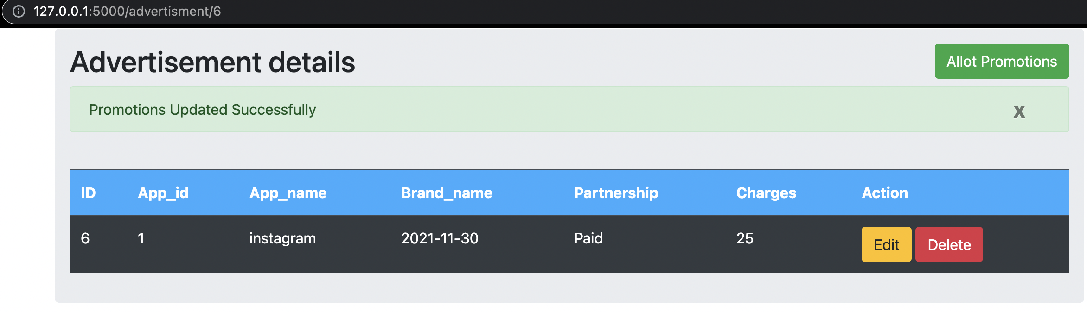

*Update the promotions information*

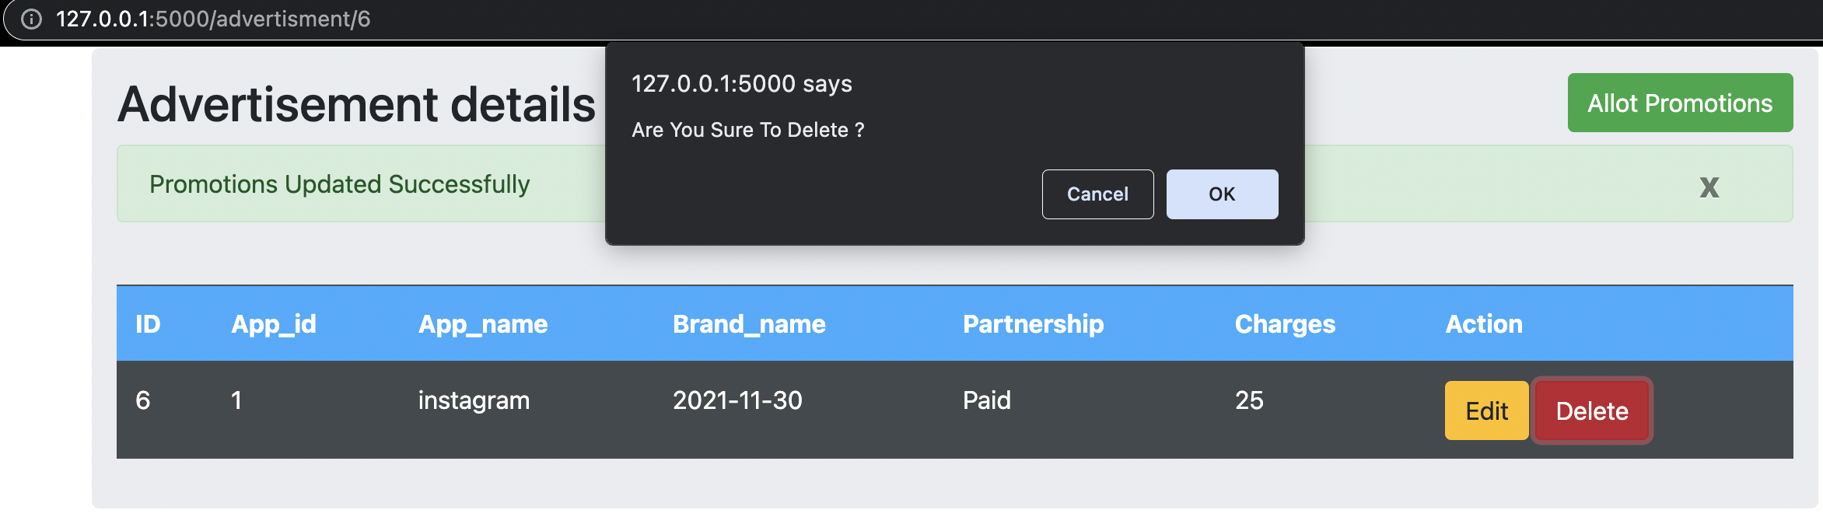

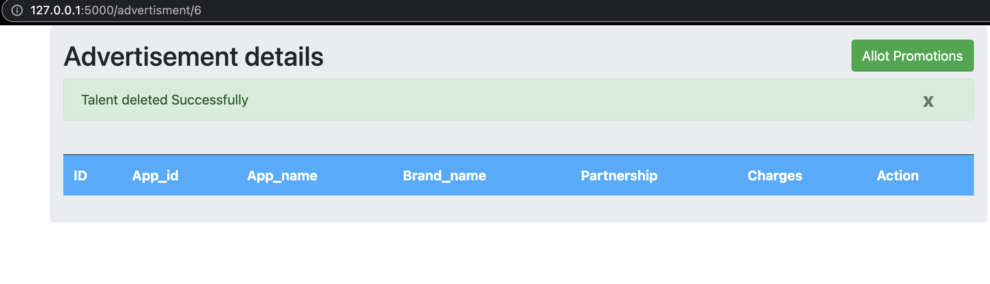

*After the data has been deleted.*

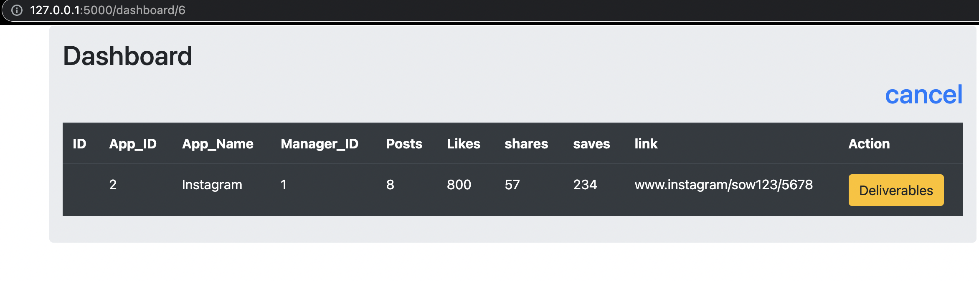

**MYSQL workbench sceenshots:**

